Amanda Ann Cooksey (Musician)
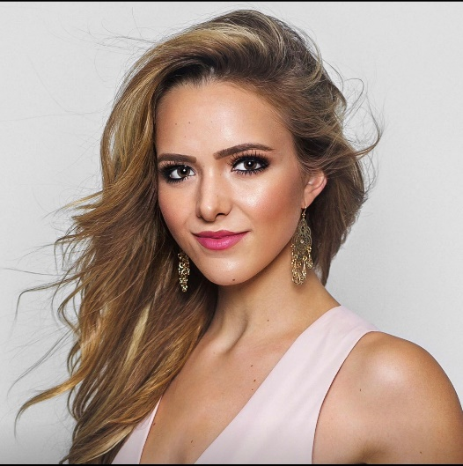
Amanda Cooksey (born May 20, 1996) is a singer/songwriter and creative assistant based in Nashville, Tennessee.
Working at Demolition Music Publishing, she is in charge of social media and its entire music catalogue. She pitches songs from the music catalogue written by staff writers of Demolition Music to major label artists. The company recently landed a song on a Netflix film.
She also collaborates with other singer/songwriters, including, but not limited to Clay Mills, Marty Dodson, and Danny Myrick to create songs, while performing in and around Nashville at different venues.

Amanda Cooksey

Education Belmont University
University of Florida
Born May 20, 1996 (age 22)
Place of Birth Orlando, FL
Location Nashville, TN
Gender Female
Occupation Singer/Songwriter
Creative Assistant
------------------------
Musical Career
Years Active 2012 - present
Genres Country/Pop
Label Independent
Agent Dan Talent Agency
Website www.amandacooksey.com
--------------------------------------
Alias(es) Amanda Cooksey
Height 5’7”

Early Life & Education
Amanda Cooksey was born and raised in Orlando, Florida and grew up in the suburb of Longwood. Her mom was the first generation of the family born in the United States, as her grandparents were immigrants from Italy, while her dad’s family were all born and raised in the south.
Since she was six years old, Cooksey has been playing the piano and taking vocal lessons, developing her love and passion for music.
Cooksey attended a private catholic school in the eighth grade, where there she was able to develop her worth ethic, making lifelong friends who shared similar values.
She then transferred to public high school where she utilized the skills and values learned from catholic school to excel at both academics and sports. Cooksey played basketball, softball, soccer, and ran cross-country at the varsity level, achieving the freshman record for fastest 5K time.
After three years, Cooksey traded in her sneakers for heels, entering into beauty pageants. She was crowned Miss St. Petersburg USA 2014 and went on to compete in Miss Florida USA. While running from sport to sport, she still found time to participate in the Girl Scouts of America.
On her journey of learning how to perfect the guitar and write her own music, she eventually moved to Nashville, Tennessee, where she attended Belmont University, receiving her Bachelor’s degree within two (2) years, so that she could devote more time to music.
Simultaneous to earning her Bachelor’s degree in business, Cooksey had the privilege of studying abroad in Florence, Italy, studying International Business, while learning about the musical influences of Italian society and culture.
As of the Fall 2018, she currently attends the University of Florida, on her pathway to earning her Master’s degree in public relations.

Career

Singing and Songwriting
Amanda begin writing songs at the age of 12 with the help of her piano/vocal instructor, who encouraged her to start performing at venues to share her original music with others.
Amanda has performed at Belcourt Taps, The Listening Room, The Row, Live Oak, Tin Roof, and Opry Mills in Nashville, Tennessee.
Amanda has performed with Tunes for Tots at various locations throughout the United States such as BB Kings Orlando, House of Blues Nashville, to benefit Make A Wish.
In February 2013, she was placed on Nashville Songwriters Association International Ones to Watch list. She opened for Michael Ray in his hometown of Eustis, Florida.
She also played in the VIP area in South Florida during the Dierks Bentley Sounds of Summer Tour.

Public Relations and Creative Assistance

After graduating in 2016, she began working at Demolition Music Publishing, cataloguing music and expanding the company’s social media platforms.
Amanda pitches songs from the catalogue, written by the staff writers to major label artists at meetings.
She has also been collaborating with other Nashville writers through ASCAP to create music and performing around Nashville.

Philanthropy
Amanda started Manda’s Musical Hope, her own non-profit in 2014 to aid families affected by cancer, as she watched her uncle battle and overcome lung cancer, and witness her piano/vocal instructor fight and lose the battle against brain cancer.
She hopes to help raise awareness of the emotional and financial struggles about the struggle families go through due to this illness with her music through fundraising in the future.

Media Appearances
https://occhimagazine.com/feature-songstress-amanda-cooksey-talks-about-writing-from-the-heart-life-love-experiences/
https://theamemagazine.com/radio/amanda-cooksey/
https://es.calameo.com/read/000466640934615e40e74?page=50
https://us.blastingnews.com/showbiz-tv/2019/01/lyrical-prowess-interview-with-songwriter-amanda-cooksey-002828527.amp.html?__twitter_impression=true
https://southernfellow.com/amanda-cooksey/
https://www.musicrow.com/wp-content/CBOcharts/CBOChart102617.pdf
http://nashnews15.weebly.com/home/meet-amanda-cooksey
https://countryroutesnews.blogspot.com/2017/07/singer-songwriter-amanda-cooksey-shares.html
https://www.imdb.com/name/nm9269331/
https://www.queensofcountry.net/home/driving-me-crazy-amanda-cooksey

Awards & Accomplishments

2010 Lake Mary High School Freshman Record for the 5K
Miss St. Petersburg USA 2014, Miss Nashville USA 2016
Write with a Hit Maker 2018
Cooksey has a large following on social media. As of 2019, her Facebook has 18K followers and her Instagram has accumulated 19K FOLLOWERS.

Personal Life
Favorite Sport(s): Cross-Country/Track
Favorite NFL Team: Tennessee Titans
Favorite Movie(s): Jurassic Park and The Amazing Spiderman
Favorite TV Show(s): The Office and The Tonight Show
Favorite Pastime(s): Running and Netflix
Cooksey enjoys all genres of music, finding something to dance and move to in hip-hop/R&B, rap, pop, country, and the oldies. Some of her favorite artists include Dean Martin, Carrie Underwood, Ariana Grande, and Post Malone.

Discography
- Upside Down (2018)

Singles/Eps
- Girl in the Mirror (2018)
  - Explores the struggles of accepting yourself
  - Over 9,000 streams on Spotify

- Upside Down (2018)
  - Explores reality of falling for the wrong person
  - Over 2,000 streams on Spotify

Tours
Festivals (various artists)
- Tennessee State Fair (2014)
Opening Act
- Michael Ray – Hometown Songwriters (2013)

